EECE 588 Spring 2019 Homework 1

Due: 3/12/19 in Class (2:00 pm)

EE 20182737

Lee Jong Geon

**1.**

a.



b.



c.



d.



**2.**

a.

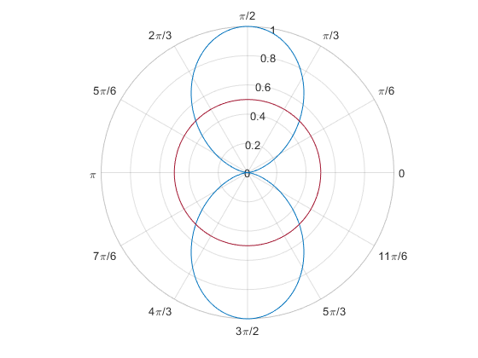

Beamwidth = 2.36-0.79 = 1.57 (rad)

= 90°

b.

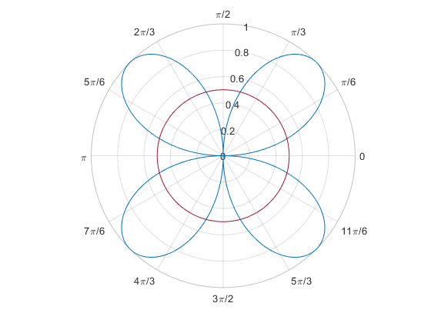

Beamwidth = 1.31-0.26 = 1.05 (rad)

= 60.2°

c.

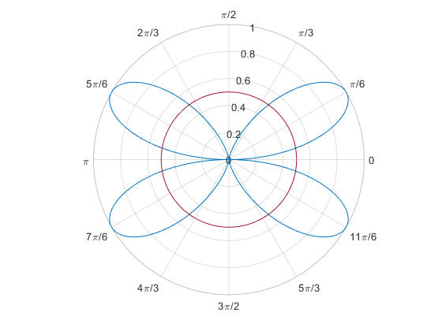

Beamwidth = 0.95-0.17 = 0.78 (rad)

= 44.7°

d.

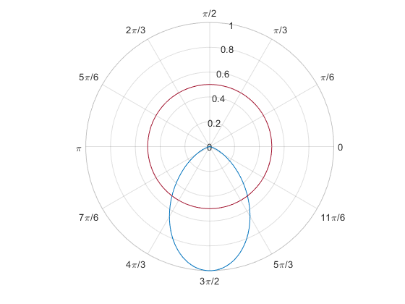

Beamwidth = 5.36-4.05 = 1.31 (rad)

= 75.1°

**3.**

a. $\vec{E}\left(x,y,z,t\right)=\left(3\hat{x}-j2\hat{y}\right)\cos\left(ωt-kz\right)=3\hat{x}\cos\left(ωt-kz\right)-2\hat{y}e^{j\frac{π}{2}}\cos\left(ωt-kz\right)$

$E_{x}=Re\left[E\right]=3\hat{x}\cos\left(ωt-kz\right),$

$E_{y}=Re\left[-2\hat{y}e^{j\frac{π}{2}}\cos\left(ωt-kz\right)\right]=-2\hat{y}\cos\left(\frac{π}{2}+ωt-kz\right)=-2\hat{y}\sin\left(ωt-kz\right)$

Consider $ωt$ for configure right- or left- hand

-> **Left-hand circular polarization**

b. $\vec{E}\left(x,y,z,t\right)=\left(\hat{x}+\hat{y}\right)\cos\left(ωt-kz\right)$

$E_{x}=E_{y}$

-> **linear polarization**

c. $\tilde{E}\left(z\right)=\left(3\hat{x}+3e^{j\frac{π}{2}}\hat{y}\right)e^{-jkz}$

$\vec{E}\left(z,t\right)=\left(3\hat{x}+3e^{j\frac{π}{2}}\hat{y}\right)e^{j\left(ωt-kz\right)}$

$E_{x}=Re\left[3e^{j\left(ωt-kz\right)}\right]=3\cos\left(ωt-kz\right), E_{y}=Re\left[3e^{j\left(\frac{π}{2}+ωt-kz\right)}\right]=3\cos\left(\frac{π}{2}+ωt-kz\right)=3\sin\left(ωt-kz\right)$

Consider $ωt$ for configure right- or left- hand

-> **Right-hand circular polarization**

d. $\tilde{E}\left(z\right)=\left(\hat{x}-j\hat{y}\right)e^{-jkz}=\hat{x}e^{-jkz}-\hat{y}e^{j\left(\frac{π}{2}-kz\right)}$

$\vec{E}\left(z,t\right)=\hat{x}e^{j\left(ωt-kz\right)}-\hat{y}e^{j\left(\frac{π}{2}+ωt-kz\right)}$

$E_{x}=Re\left[\hat{x}e^{j\left(ωt-kz\right)}\right]=\hat{x}\cos\left(ωt-kz\right), E_{y}=Re\left[-\hat{y}e^{j\left(\frac{π}{2}+ωt-kz\right)}\right]=-\hat{y}e^{j\left(\frac{π}{2}+ωt-kz\right)}\sin\left(ωt-kz\right)$

Consider $ωt$ for configure right- or left- hand

-> **Left-hand circular polarization**

**4.**

Communication system at 10 GHz

One major lobe, ideally no minor lobes or can be neglected.

The pattern symmetry to the azimuthal.

Half-power beamwidth of 10 degrees.

Exists only the upper hemisphere.

SOLVE:

a.

$${\cos^{n}\left(θ\right)}_{θ=θ_{h}}=0.5$$

From the problem, $2θ_{h}=10°$. Therefore ${\left(0.99619\right)}^{n}=0.5→ n=181.58$

b.

$$P_{rad}=2π\int_{0}^{π/2}{\cos^{n}{θ}\sin{θ}dθ}={\left[-\frac{\cos^{n+1}{θ}}{n+1}\right]}_{0}^{π/2}=0.0346$$

$$D_{max}=\frac{4πU_{max}}{P_{rad}}=\frac{4π*1}{0.0345}=363.1=25.60 dB$$

5.

A communications satellite stable altitude = 22370 miles=36001 km = 3.6e+7 m

Transmits with 8.0 W of power

The receiving antenna is a 210 ft.

Assume the transmitter antenna is isotropic. -> Directivity=1

The both antennas are impedance matched, resistive losses are negligible.

Mismatch polarization: 8-degree tilt between the 2 antennas.

*From the book, at a frequency 2 GHz -> 0.15 m

SOLVE:

a. $p_{r}=\frac{P_{t}}{4πR^{2}}=\frac{8.0}{4π*(3.6e+7)}=4.91e-16 W/m^{2}$

b. Use the Friis transmission formula (eq. 2-117)

$$P_{r}=P_{t}e_{cdr}e_{cdt}\left(1-{\left|Γ_{t}\right|}^{2}\right)\left(1-{\left|Γ_{r}\right|}^{2}\right){\left(\frac{λ}{4πR}\right)}^{2}D_{t}D_{r}{\left({\hat{p}}_{t}∙{\hat{p}}_{r}\right)}^{2}=8.0*1*1*1*1*{\left(\frac{0.15}{4π*3.6e+7}\right)}^{2}*1*{10}^{6}*{\left(\cos{8°}\right)}^{2}=8.78e-13 W$$